NYC EMS Incident Dispatch Data Analysis
Jeff Hackmeister

ALY 6140 Capstone Project
Dr. Michael Prokle
Northeastern University
2026-05-15

Introduction
Emergency Medical Services (EMS) is a critical component of urban and suburban public health. The speed and efficiency of EMS units can often be the difference between life and death for people experiencing medical emergencies, especially acute cases such as cardiac arrest, stroke, or traumatic injuries. In large metropolitan areas, such as New York City, factors such as population density, traffic congestion, geographic dispersion, and socioeconomic disparity not only cause additional complications to EMS response, but they are also vital factors in designing and maintaining a system that provides efficient and effective service to all communities.
This project analyzes the Emergency Services Incident Dispatch Data published by the New York City Fire Department (FDNY) through the NYC Open Data portal. The dataset is generated by the EMS Computer Aided Dispatch (CAD) system and spans all incidents from call creation through closure. For this analysis, the dataset has been filtered to include the years 2023 through 2025, which provides a post-pandemic baseline that reflects current operations readiness of the EMS system in New York.
The goals of this project are to first characterize the distribution and geographic variation of EMS calls across New York City and its five boroughs. Second, identify factors most strongly associated with response time, with particular attention to temporal patterns and borough-level disparities. Third, analyze the current distribution of demand and determine if there are areas of opportunity to improve resource allocation across the city. These goals are driven by a desire to help achieve a socially responsible and sustainable EMS system in New York City that balances the needs of all residents and visitors to the city, while providing a data-driven approach that can serve as an ongoing tool for local leaders.
To achieve these goals, the analysis relies on three statistical methods; multiple linear regression to model response time as a function of borough, time of day, day of week, and call type; K-Means clustering to identify demand patterns across borough-hour combinations that can inform resource allocation decisions, and Kernel Density Estimation (KDE) to characterize the distribution of response times and identify incidents that exceed an operationally meaningful severity threshold. Together, these methods provide insight into what drives response time and when and where demand is highest.

Exploratory Data Analysis

Data Extraction and Description
The raw dataset contains approximately 28.7 million rows across 31 columns, spanning multiple years. Prior to downloading, the dataset was filtered through the NYC Open Data portal to include incident dates with an INCIDENT_DATETIME between January 1, 2023, and December 31, 2025. The filtering was done at the portal level to reduce the file size before local import and resulted in a dataset of 3.19 million rows. Of the original 31 columns, the following were retained for analysis:
- INCIDENT_DATETIME – the timestamp of call creation
- FINAL_CALL_TYPE – the nature of the incident entered the CAD system at call closure
- INCIDENT_RESPONSE_SECONDS_QY – the elapsed time between call creation and the first arriving unit, this is precalculated by the CAD system
- BOROUGH – the NYC borough in which the incident occurred
- ZIP CODE – the ZIP code in which the incident occurred
From those columns, the following variables were calculated and added to the dataset at the row level.
- HOUR – the hour of the day when the incident occurred
- DAY_OF_WEEK – the day of the week the incident occurred
- MONTH – the calendar month the incident occurred
- YEAR – the year the incident occurred
- RESPONSE_TIME_MIN – the elapsed response time in minutes, calculated by dividing INCIDENT_RESPONSE_SECONDS_QY by 60

Data Cleaning
Data cleaning involved two primary steps. First, the INCIDENT_DATETIME field was parsed to datetime format using an explicit format string (%m/%d/%Y %I:%M:%S %p’) to ensure consistent parsing and avoid performance warnings associated with format inference. Secondly, an outlier policy was applied to response times. Records with a response time of 0 or less, which can indicate a CAD error or an incident that occurs where a unit is already positioned, were excluded. Additionally, response times exceeding 120 minutes were excluded as they most likely indicate a CAD error or extraneous circumstance that is outside the scope of this study. The filter was applied as follows:
df = df[(df['RESPONSE_TIME_MIN'] > 0) & (df['RESPONSE_TIME_MIN'] <= 120)]
A missing data assessment was also conducted using a custom missing_data_report() function. The borough and call type fields showed minimal missing data, while ZIP code had a higher rate of missing data. As such, locational study was kept at the borough level for the study, which was in line with the original intent.

Data Visualization
Figure 1 displays incident volume by borough. Brooklyn leads the study period with approximately 928,600 incidents, followed by Manhattan, Queens, the Bronx, and Richmond/Staten Island. Notably, the Bronx’s volume is high relative to its population, suggesting an elevated per-capita demand compared to the other boroughs. These volumes are generally consistent with population differences, though the Bronx stands out as an outlier on a per-capita basis.
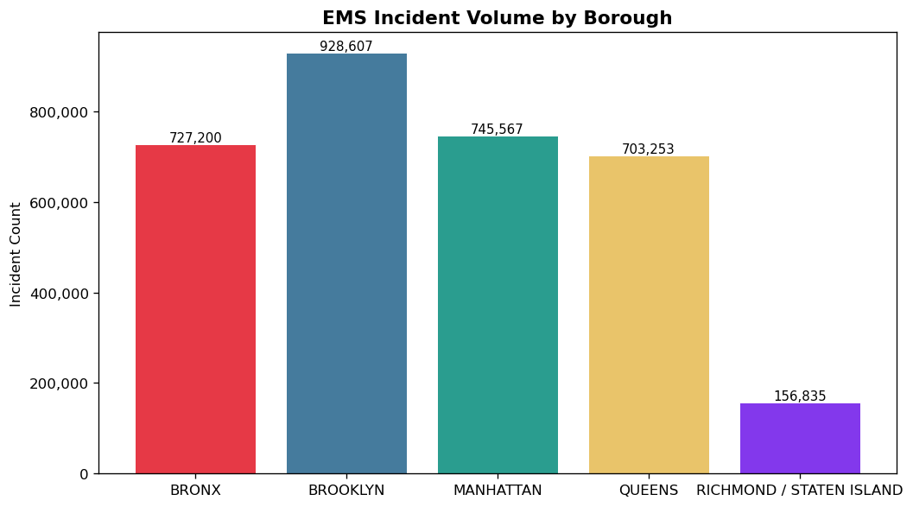
Figure 1 Incident Volumes by Borough
Figure 2 shows the distribution of incidents over the hour of the day. There is a noticeable dip in the early hours of the day, peaking at 11am but remaining consistent throughout the end of the day.
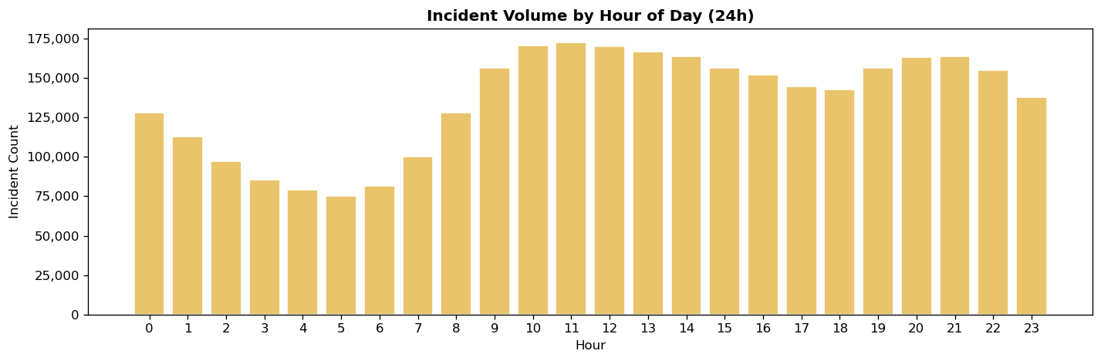
Figure 2 Incident Volume by Hour of Day
Figure 3 shows the top 20 call types in the dataset. Sick and Injury are by far the largest categories while EDPM (Psych patient – Non-violent), Other, and CVAC (Stroke – Critical) as the least frequent in the group.
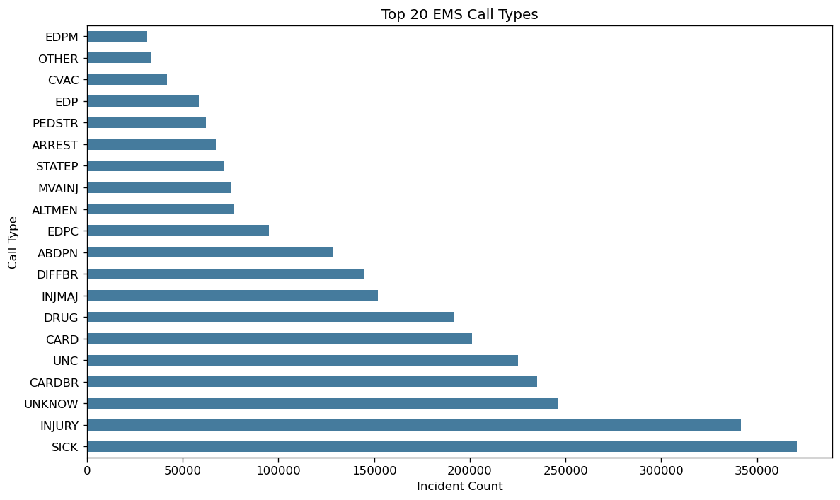
Figure 3 Top 20 Call Types
Figure 4 is a volume heatmap for hour of day and day of week. This shows a similar pattern to the hour of day chart in figure 2 but also shows that volumes are lower on weekends compared to weekdays.
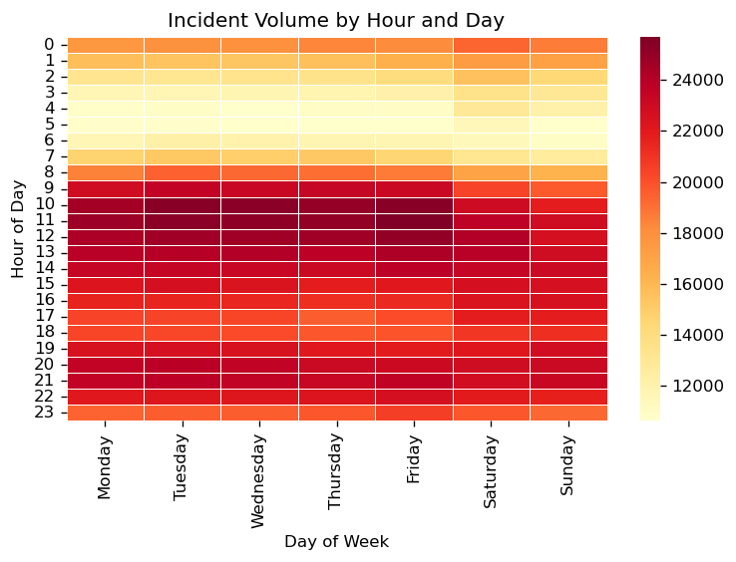
Figure 4 Incident Volume Heatmap
Figure 5 is a boxplot of the incident response time by borough. Richmond/Staten Island stands out with the lowest median response times. Among the remaining four boroughs, the Bronx and Queens have the highest medians, while Manhattan and Brooklyn are somewhat lower. All five boroughs also show a significant number of outliers at the extreme high end, indicating that delayed responses occur across the entire city.
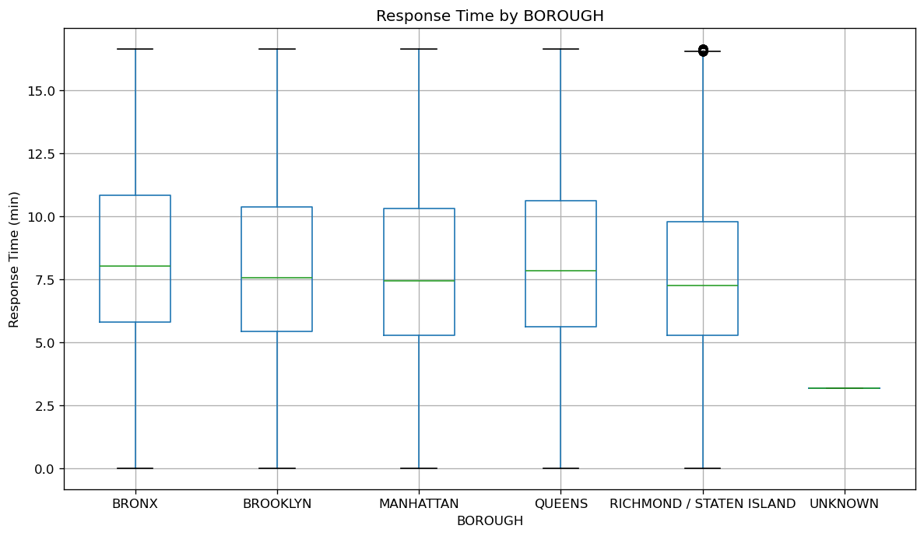
Figure 5 Response Times by Borough
Median times and rank are shown in Figure 6.
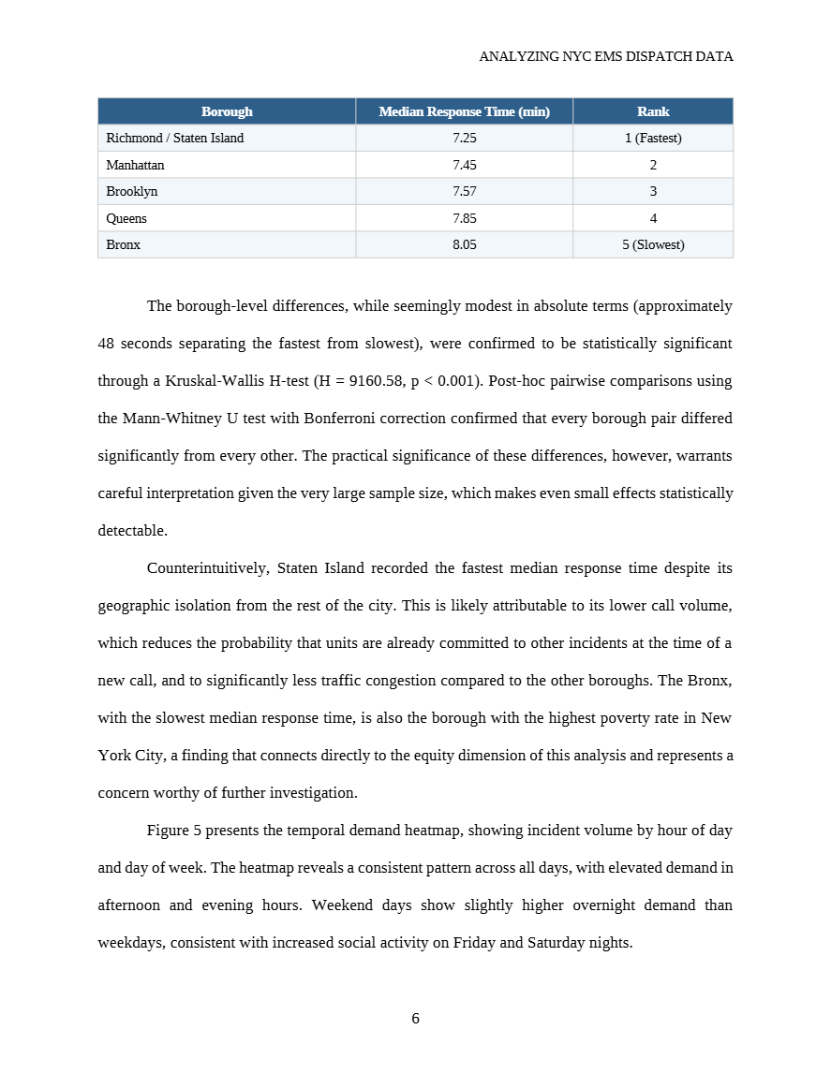
Figure 6 Median Response Times
The differences are modest — less than one-minute separates the fastest from the slowest borough — but in EMS, very small differences in response time can have a meaningful impact on patient outcomes. To test whether these differences are statistically significant, a Kruskal-Wallis H-test was performed, yielding H = 11,448.46 (p ≈ 0), confirming that response times differ significantly across all five boroughs. The full results are below:
Kruskal-Wallis H = 11448.46, p = 0.0000e+00
→ Statistically significant difference in response times across boroughs (p < 0.05).
Post-hoc pairwise comparisons (Mann-Whitney U with Bonferroni correction):
BRONX vs BROOKLYN adj-p = 0.0000e+00 ***
BRONX vs MANHATTAN adj-p = 0.0000e+00 ***
BRONX vs QUEENS adj-p = 2.7024e-223 ***
BRONX vs RICHMOND / STATEN ISLAND adj-p = 0.0000e+00 ***
BROOKLYN vs MANHATTAN adj-p = 8.2179e-73 ***
BROOKLYN vs QUEENS adj-p = 0.0000e+00 ***
BROOKLYN vs RICHMOND / STATEN ISLAND adj-p = 4.1261e-226 ***
MANHATTAN vs QUEENS adj-p = 0.0000e+00 ***
MANHATTAN vs RICHMOND / STATEN ISLAND adj-p = 1.6277e-94 ***
QUEENS vs RICHMOND / STATEN ISLAND adj-p = 0.0000e+00 ***

Predictive Models

Model 1: Multiple Linear Regression for Response Time
The first model uses multiple linear regression to predict EMS response time as a function of borough, hour of day, day of week, and incident call type. Linear regression is appropriate here because it provides both a predictive framework and directly interpretable coefficients. This allows each variable to be considered while holding other factors constant.
A log transformation was performed to account for the right skewedness of the data, this is a commonly used approach with response times. The dataset was split into training (80%) and testing (20%) sets using a fixed random seed for reproducibility. The model was fit on the training set and evaluated on the test set using Root Mean Squared Error (RMSE) and R-Squared (R2). The results are quite poor for this model, with an RMSE of 0.4163 and R2 of 0.0013 – indicating that the model explains roughly 0.13% of the variance in data. The results of this model illustrate the difficulty of predicting EMS response times and that there are likely many factors outside of what is available in the CAD data that impact these times.

Model 2: K-Means Clustering for Resource Allocation
The second model uses K-Means clustering to identify natural groupings of demand patterns across borough-hour combinations. Unlike the regression model, K-Means is an unsupervised method that discovers structure in the data without a specific target – which makes it well-suited for resource allocation analysis.
The feature matrix for clustering was constructed by aggregating data by borough and hour, with total incident count and average response times calculated for each combination. To determine the optimum number of clusters, an elbow plot was generated by fitting K-Means models for k values from 2 to 10 and recording the within-cluster sum of squares for each. The elbow in the curve indicated that k=5 was a reasonable choice.
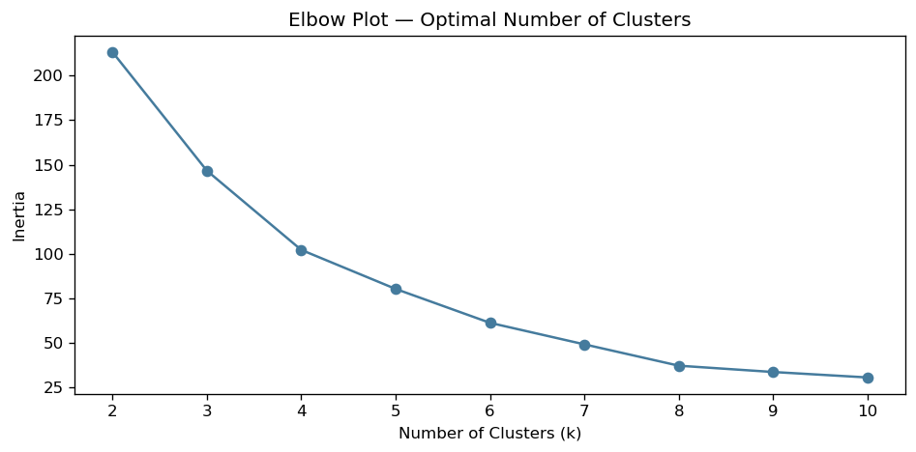
Using k=5 for the model, we see that the true differences in response time come from borough, with time of day having a much smaller impact on results.
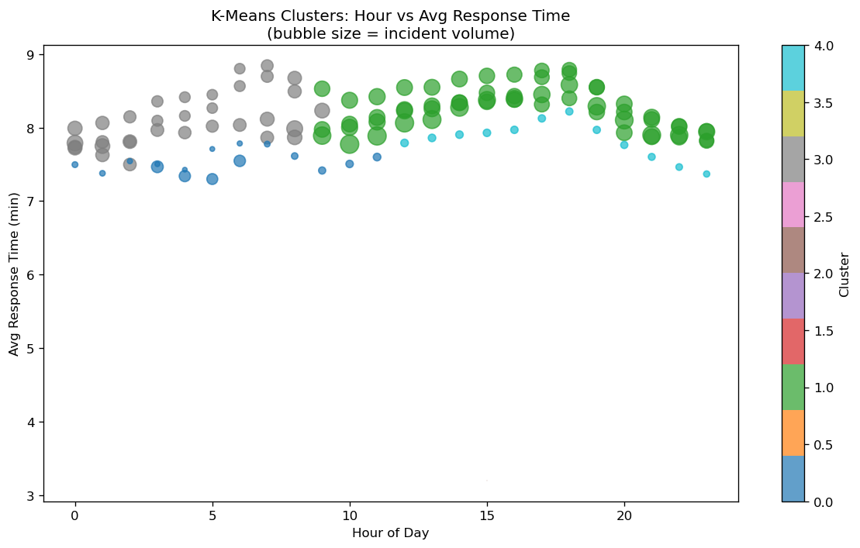

Model 3: Kernel Density Estimation for Severity Analysis
The third model uses Kernel Density Estimation (KDE) to characterize the distribution of response times and identify incidents that exceed a severity threshold. KDE is a non-parametric method that estimates the probability density function of a continuous variable by placing a kernel at each observation and summing the contributions.
For this analysis, incidents were classified into two severity categories: Normal (response time below 10 minutes) and High (response times above 10 minutes) – this was chosen as an industry standard. KDE curves were plotted for each severity group together for comparison.
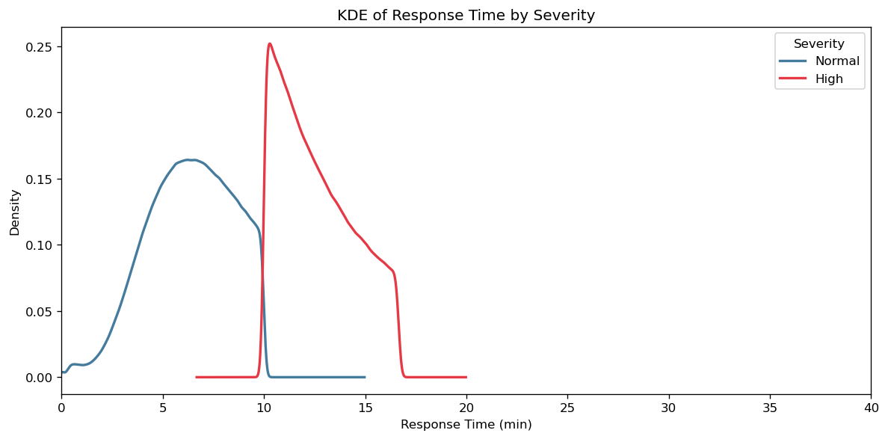
The resulting graph shows a predictable split, with the High severity spiking at the 10-minute indicator set by the study, with a considerable tail of incidents that extends to nearly 20-minute responses. When applied to a heatmap by borough, we see that Brooklyn and the Bronx have the highest concentration of these high severity incidents, particularly in the midday to evening time periods.
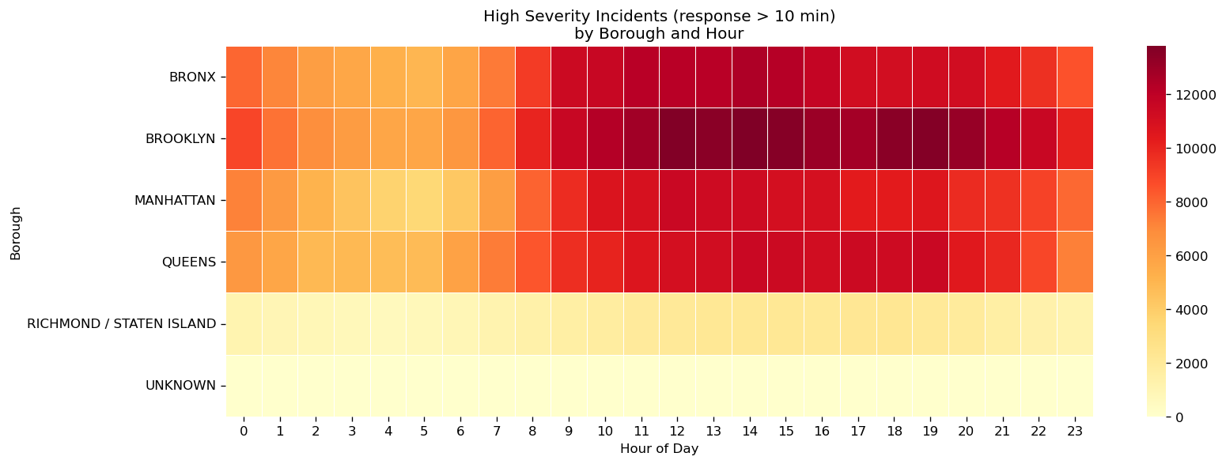

Interpretation and Conclusions
This study underlines the complexity of emergency response data. The regression model’s low R2 score demonstrates that there are likely many additional variables that need to be considered when trying to predict response times. The K-Means clustering analysis showed that the response times of each borough were statistically different, but that time of day was not as significant a player in those differences.
Call type distribution varies across all boroughs of the city, but the study does show that there are response inequities between the boroughs. The Bronx, the most economically disadvantaged of the five, sees the slowest average response times, the highest concentration of high-severity responses, and the second-highest total call volume (despite having the second-lowest population, ahead of only Richmond/Staten Island). These results, while limited, point to a need for additional resources in the Bronx to better prepare EMS crews for the call volumes experienced there and to better serve the needs of that community.
Future enhancements to this work would include bolstering the dataset to include unit location at dispatch data as well as local traffic and weather data to better understand the factors that impact longer response times. Despite the limitations of the available data, this study demonstrates that systemic analysis of EMS dispatch data can be very valuable to civic leaders looking to improve the performance of their EMS systems.

Resources
Fire Department. (2016, October 18). EMS Incident Dispatch Data. Cityofnewyork.us. https://data.cityofnewyork.us/Public-Safety/EMS-Incident-Dispatch-Data/76xm-jjuj/about_data
McKinney, W. (2022). Python for data analysis (3rd ed.). O’Reilly Media.

